Imperialism in India: A Case Study
One of the best ways to learn about imperialism is to concentrate on an in-depth case study of a country before, during, and after it was colonised. This allows us to examine how imperialism changed a nation over time. India is an excellent candidate for such a case study on imperialism because it was by far the most valuable colony of the most powerful empire—the British Empire. It all started with a small global trading company—the East India Company—that grew and grew and eventually conquered much of South Asia. Before long, India became the “jewel in the crown” of the largest empire in the history of the world.

This case study raises some important questions about the imperial experience.

How did a small company of a small nation take control of India?

How did Indians respond to foreign intervention?

How did imperialism change India?

What was the legacy of British imperialism?

Should the British be praised or condemned for their imperial efforts in India?

Early Modern India: The Mughal Empire
When small European ships first landed on the shores of South Asia in the early 1600s in search of spices, they encountered merchants on the periphery of the Mughal Empire (1526-1858), a kingdom larger and more powerful than any country in Europe at the time. The Mughals ruled over a vast and diverse land of deserts, large navigable rivers, thick forests, plateaus, grasslands, and mountains.
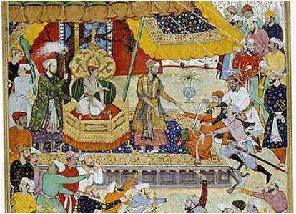
Many of these physical barriers separated various linguistic, religious, and ethnic groups. There were religious Sikhs in the Punjab to the West, Muslims in Bengal to the East, Hindu Maratha tribes in the Deccan Plateau, Tamil speakers in the South, and Hindu princes in Hyderabad. The highest mountains in the world—the Himalayas—blocked interaction with China. Invaders, before the British, came overland from the northwest from what is today Pakistan, Afghanistan, and Iran. Conquerors from these lands brought cultural influences such as Islam, the Persian language, and Afghani ethnic groups. The hub of the Mughal Empire was in the densely populated northern region along The Ganges River Basin. The rich soil and river system there was ideal for farming, transportation, and communication. The Mughal Empire’s weakest presence was along its coasts and this would be one cause of its eventual downfall.
To rule this diverse and vast land successfully the Mughal emperors often shared power with regional leaders. Unlike the Hindu majority, the Mughal rulers were Muslims of Afghan origin who spoke a Turkic language and were culturally influenced by Persia. As foreign monarchs, they needed cooperation of local rulers. For example, the most famous Mughal Emperor, Akbar (1556 -1605), enlisted Hindu Rajput warriors from the south to help build the empire. Rajput princes owed allegiance to the Emperor. But they administered their own territory and maintained the right to keep their regional customs and language (Asher 126). In this way, the Mughal tradition of involving local rulers in governing also had the effect of encouraging regional ethnic, linguistic, and religious differences. This strong regional identity throughout India prevented the growth of a single unified culture. It may have been Akbar’s awareness of the Mughal’s Muslim minority rule that encouraged him to implement policies in favour of religious tolerance. He enlisted Hindus and Jains into leadership positions and gave them equal rights as Muslims and even allowed a Jesuit Priest to teach him about Christianity (124).
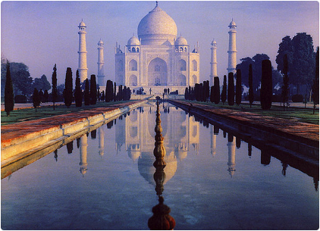
Akbar and succeeding Mughal emperors established a politically and economically stable state by relying on regional leaders to collect revenue and govern. Local nobles, known as nawabs, agreed to supply taxes and military support to the Mughal rulers in return for a jagir —the right to control the revenue of a region (Peers 17). Like early modern China, India was primarily an agrarian land empire. Akbar taxed fifty percent of the agricultural yield, and peasants had to pay in a new silver coinage (Asher 128). By demanding that taxes be paid in cash, the emperor brought peasants into the market economy. By 1605, Akbar had left behind an empire of over 110 million people and a large army demanded 80% of the Mughal budget. The economy thrived. For example, scholars estimate that India traded 400,000 articles of cloth to Indonesia for spices in just one year in the early 1600s (182). Mughal emperors in the 17th century lavished their wealth on many of the greatest architectural achievements in Indian history, such as the world famous Taj Mahal.
The Mughal Empire reached its peak around 1700 and for several reasons began to decline just as the British began to increase their presence. First, the majority Hindu population resented new religiously intolerant policies—such as increased taxes on non-Muslims. Second, emperors spent the wealth of the Empire fighting a prolonged military campaign in the South. The Hindu Marathas humiliated the powerful Mughal Empire for decades with unrelenting guerrilla tactics. As a result, the Empire went into debt and demanded more revenue from its nawabs elsewhere. Regional princes and religious groups, such as Hindus and Sikhs, resented Mughal leadership, sensed weakness, and looked for opportunities to break away (Asher 225-230). Third, the Empire weakened just when Europeans began to seek more profitable ways to extract revenue. Regional nawabs turned to Europeans for military support for short-term gain against other Europeans, local nawabs, or the Mughals. Coastal merchants grew wealthy from European gold and silver and became dependent on European trade. Fourth, since the Mughals traditionally received their revenue from agricultural taxes inland, they were uninterested in the burgeoning trade occurring at the shore. As a result, they had no navy at all guarding the coast. When the Europeans sailed to India, they found little evidence of an empire at all. On the periphery of the Mughal Empire, coastal merchants traded cotton textiles to the Middle East and South East Asia. India was well known throughout Eurasia for its high quality of manufactured goods.
By the middle of the 18th century, the Mughal Empire was a shadow of its glorious past. It could no longer hold off invaders from the northwest. In 1739, a Persian king sacked Delhi, the capital of the Empire, killing 20,000 people. The Persians stole the royal jewels, including the Darya-e Noor diamond, one of the oldest and largest diamonds in the world. As of 2012, the Darya-e Noor was still on display in Tehran, Iran; the Persians never returned it. They also took the famous peacock throne (Asher 253). Then the King of Kabul (Afghanistan) attacked Delhi in the 1750s and 1760s (255). After that, the Mughal Empire still claimed sovereignty over large areas but in practice was simply the seat of a small kingdom (247). For the next hundred years, independent successor states acknowledged Mughal rule but paid little or no tribute.
Unlike China, India had never been politically unified. The land and people were too vast and diverse. Before the Europeans arrived, no enemies had ever invaded India from the sea. Europeans came slowly at first in search of trade rather than invasion. They sought valuable spices from what they called the East Indies.

The Spice Trade

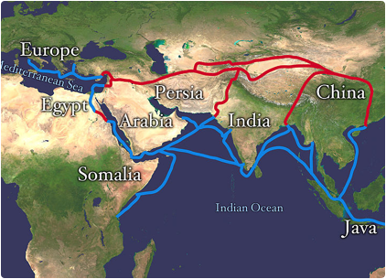
When Europeans first sailed to India, they came looking for spices. Since ancient times, Europeans had shown a willingness to pay dearly for rare flavours that came from mysterious places in the East. We know, for example, that a series of merchants regularly travelled 5000 miles to bring black pepper from ancient India to Imperial Rome (Turner 65). In addition to pepper, Europeans in the Middle Ages craved Sri Lankan cinnamon, Indian ginger, and cloves and nutmeg from tiny islands in eastern Indonesia (known as the “spice islands” to Europeans). Medieval Europeans used spices to improve the taste of food, balance the taste of salty winter meat, enliven wine and ale, treat illness, and even preserve corpses (150). The secrecy of their origins, the low supply, and the distance from Europe made them very difficult for Europeans to obtain and therefore enormously valuable as luxury items. In 1600, for example, nutmeg increased 32,000 percent in value from its origin in Asia to markets in England (Keay 4). It’s no wonder then that in the 16th century, the Spanish and Portuguese raced to find the source of nutmeg and cloves amongst the thousands of islands of present day Indonesia.
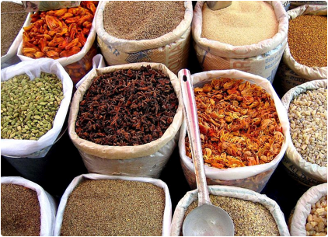
After competing and warring with other European countries and ruthlessly conquering many key islands, the Dutch emerged as masters of the spice trade in the 17th century. The British agreed to give up their claims in modern day Indonesia and in return the Dutch gave them the island of Manhattan. Pushed aside, the British merchants settled on the shores of India as a plan B. In the late 18th century, the French stole nutmeg and clove seedlings and began to plant them in other territories with similar climates (Turner 296). The Asian monopoly on their native spices broke down as other countries followed suit. Today, these spices and others are grown around the world and they still provide zest and mystery to food and drinks. Even the secret formula for Coca Cola reportedly calls for cinnamon and nutmeg (Turner 310).
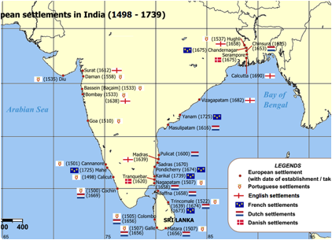

The English East India Company

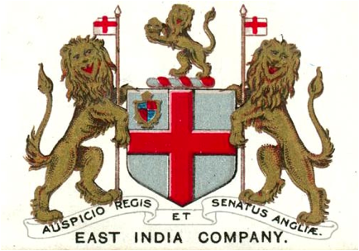
“Though our business is only trade and security, not conquest, yet we dare not trade boldly or leave great stocks where we have not the security of a fort”
—Directors of the East English Company (Keay 141).
The English East India Company (1600-1874) was the most influential company in the history of the British Empire. From the outset, it was a peculiar mix of a private and government enterprise. In 1600, 218 British investors successfully petitioned Queen Elizabeth I to approve a royal charter.
The Company asked for and received a monopoly on all English trade in Asia—102 years after da Gama discovered the sea route to the Indian Ocean (Robins XIV). But, in return, the crown would regulate the Company as it saw fit and the British Parliament would have to renew the charter every twenty years. The goal of the company was always very clear—to make a profit for its shareholders by taking advantage of its monopoly on Asian trade. To that end, its royal charter granted the small private company unusual governing powers, including the right to mint coins, establish and execute justice, and even wage war if necessary (Robins 28). Though it started with a couple hundred investors and a few ships, in time it came to rule India. The investors hoped to hire a crew to sail to the East, trade for nutmeg or pepper, and make the Company a fortune.
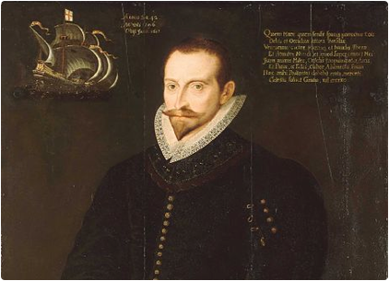
The English East India Company first set out to make a profit by engaging in the lucrative spice trade. On the maiden voyage in 1601, a few ships sailed to tiny islands in the far east of the East Indies (Indonesia) and traded gold bullion for 500 tons of pepper (Keay 24). The unusual voyage was the talk of London. The king knighted the captain, even though he had lost 40% of his crew to illnesses, such as scurvy and malaria (24). In 1603, the company established a presence on Puloroon, a tiny two mile-long, half mile-wide island. Though small, it was the only source of nutmeg in the world. Pleased with his first overseas possession of what would become the British Empire, King James I renamed his royal title, “King of England, Scotland, Ireland, France, and Puloroon” (Turner 37). Alas, the island proved unprofitable. In the end, the British traded away their rights to Puloroon to the Dutch for the Island of Manhattan. Then crown and Company turned their gaze to the spices of India.
The Company had much more success in India than the “spice islands”. They first landed on Indian soil in 1608, and by 1618 they had secured a trade agreement with the Mughal Empire at Surat (Keay 76). The first steps were to make contacts with local merchants, build a warehouse, and then leave some settlers to secure the goods. Trade increased and so did the Company’s fortunes. By 1620, The East India Company claimed over a dozen trading posts in the Indian Ocean and 30 to 40 large ships (Keay 111-112). Indian merchants in coastal cities wanted European gold and silver. Towards the end of the 17th century, Indian pepper had become less important for global trade. The Company profited mostly from Indian cotton and Chinese silk, followed by indigo, saltpeter (for gunpowder), coffee, and tea (Robins 46). In 1684, Indian textiles accounted for 84% of all British trade from Asia (Robins 46). The British could find little that the Indians wanted in exchange (It was too hot in the tropics to wear British wool), so the Company exported tons of gold and silver to India.
With gold, silver, and textiles piled around the warehouses, trade was closely tied to security. Company ships and ports prepared to meet pirates, European and Asian, and hostile European navies. After establishing a presence at a port, the Company sought to construct a fort to protect its investment. For example, Portugal gifted the city of Bombay to the King of England as a royal dowry in 1661 (Keay 131). The directors of the Company moved their headquarters to Bombay, lured by the security of a crown colony: “Though our business is only trade and security, not conquest,” the directors wrote. “Yet we dare not trade boldly or leave great stocks where we have not the security of a fort” (141).
Emboldened by its emerging success in the late 17th century, the Company decided to conquer a slice of India, even if it meant facing the Mughal Empire in battle. The president of the Company ordered the official at Madras to “establish such a politie of civil and military power, and create and secure such a large revenue to maintain both at that place [Madras], as may be the foundation of a large, well-grounded, sure English dominion in India for all time to come” (Keay 178). But the Company’s vaulting ambition outshot its military capability. They suffered a humiliating loss to the Mughal army in 1690 and, as a result, were on the cusp of losing all rights to trade in India at any port. The Company’s peace ambassadors travelled to the Mughal court in Delhi and begged literally on their knees for peace and forgiveness. To add to the indignity, the Emperor forced them to pay a large fee to pay for the war and to win back trading rights (146). In defeat, the Company returned to its original commercial purpose. By 1700, East Indian trade accounted for 15% of all imports to Great Britain (Robins 29). Still, Company officials continued the search for commercial opportunities in the industrial heart of India.
Table of Dutch and English East India Company exports from Asia (in millions of florins (early Italian gold coins))
 | 1668-70 | 1698-1700 | 1738-40 | 1778-80
English | 4.3 | 13.8 | 23.0 | 69.3
Dutch | 10.8 | 15.0 | 19.25 | 20.8
(Robins 55)

The Turning Point: Robert Clive and the Conquest of Bengal

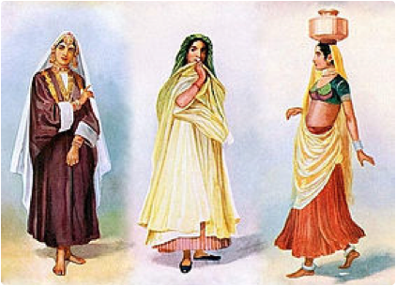
“We have at last arrived at that critical period, which I have long foreseen; I mean the period which renders it necessary for us to determine whether we can, or shall, take the whole to ourselves.”
—Robert Clive, 1765 (Peers 101).
The English East India Company sought to gain access to the province of Bengal because it was the most successful industrial region in India. In 1750, India accounted for 25% of world economic production contrasted to England’s 1.9% (Robins 61). Bengal was at the centre of that production. In 1776, in the Bengali city of Dhaka alone, 80,000 women spun cotton for 25,000 weavers who produced approximately 180,000 piece of cloth (63). Indian textiles wove their way so fully into British culture that South Asian names for cloth cropped up in the English language—such as bandana, calico, taffeta, gingham, and chintz (63). In addition to textile manufacturing, Bengal’s fertile soils of the Ganges River Basin made for outstanding agricultural production. Any company seeking a profit in India wanted a piece of the lucrative region.
The East India Company opened a port in Calcutta to access Bengali riches. In 1717, the Company bribed a feeble and short-lived Mughal Emperor to give them a farman in Bengal—a decree that gave the Company the rights to trade duty free in return for a small annual fee to the Mughal court (Keay 228-229). This “get-out-of-all-Bengali-taxes-for-free card” made it impossible for other European powers to compete with the British there. But the local Bengali rulers resented this privilege that deprived them of tax revenue. More still, the farman was granted to the Company by a distant and weak ruler—the Emperor— who had only nominal authority in the province. Despite relentless protests from the local nawab, the British increased their trading presence in Bengal. A military clash seemed likely.
Around the mid 1700s, the European military strength of Great Britain and France surpassed the Mughal Empire. A key turning point was the Battle of Madras in 1746. The French provided their soldiers with the latest muskets that could fire 20 rounds per minute. The local nawab mustered 10,000 men and expected that the Europeans could still fire only once every three minutes. Instead, the new French muskets cut down Indian soldiers at will and the nawab quickly retreated. This was the first battle in South Asia in which European weapons proved dramatically decisive (Keay 281). In the future, superior military technology would have dramatic results when combined with the British desire to further exploit the wealth of Bengal.
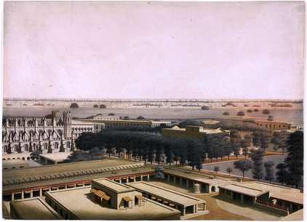
The East India Company’s conquest of Bengal began when a new nawab, named Siraj, challenged the increasing power of the British. Worried about recent French incursions along the coast, the British built Fort William in Calcutta, which infuriated Siraj: “You are merchants. What need have you for a fortress? Being under my protection you have nothing to fear” (Keay 299). Still, the British refused to stop building. So, in 1756, Siraj attacked Fort William in Calcutta with 30,000 troops. One thousand British settlers evacuated, including the military commanders, leaving one hundred or so behind. After the nawab’s soldiers easily conquered the fort, they crammed the British prisoners into a small, dark basement. The majority of the prisoners slowly suffocated to death—only 23 survived (Robins 69). A British military officer wrote a terrifying and vivid account of how he endured the “Black Hole” of Calcutta, and it created a stir back in England (Keay 300-304). The British lost Calcutta. It was a military disaster. But, the description of the treatment of the surrendered soldiers sparked wide spread public support for the subsequent conquest of Bengal.
As it turned out, it fell to a young, impetuous, and inexperienced Company colonel, Robert Clive, to change the course of British and Indian history. Fast moving events prevented the Company directors in London from efficiently communicating orders to Clive in India. It took six months on average to travel or communicate one way between India and Britain, and this was an emergency (Peers 11). As the “man on the spot,” Clive from the outset dreamed of conquest: “I flatter myself that this expedition will not end with the retaking of Calcutta only—and that the Company’s estate in these parts will be settled in a better and more lasting condition than ever” (Robins 69). He quickly retook Fort William and Calcutta with 1000 sepoys (Indian soldiers trained by the British), 800 British troops, 14 cannons, and naval support. Shortly after, the Bengali nawab returned to Calcutta with 40,000 infantry, 60,000 cavalry and thirty cannons. Surrounded and severely outnumbered, Clive heard troubling news—the French had offered military support to the Bengali prince.
With luck, pluck, and a dash of treachery, Clive turned events to his advantage at the Battle of Plassey. As chance would have it, Afghan troops sacked the Mughal capital of Delhi and were reportedly heading towards Siraj to plunder his palace (Keay 313). The attack never came, but it so worried Siraj that he left the siege of Calcutta and actually asked for British support against the Afghanis. As the nawab hesitated, Clive turned and successfully attacked the French at Chandernagar, eliminating a potential European ally of the nawab and pushing the French out of Bengal forever. Next, he co-opted disgruntled generals in the nawab’s army to agree to a secret pact. Mir Jafar, the key Bengali general, agreed to betray Siraj during battle and, in return, take the place of the nawab. At the last minute, however, one co-conspirator, a wealthy Bengali merchant, threatened to expose the secret treaty unless the cabal agreed to promise him 5% of Siraj’s treasure. This was blackmail. Clive simply prepared two treaties, a real one and a fake to fool the unreliable co-conspirator (Robins 71). The subterfuge worked.
At the Battle of Plassey, 3,000 Company troops—only one third of them European—defeated the nawab’s army of 50,000 (Keay 317). It was a sham battle; the Bengali general, Mir Jafar, betrayed Siraj. Clive fulfilled his side of the bargain and allowed Mir Jafar to ascend the Bengali throne. The co-conspirator who had been tricked by the fake treaty had a heart attack and died the moment he found out about Clive’s deceit (Robins 71). Siraj was soon found and killed. The year before, the nawab had compared the Europeans to a swarm of bees “of whose honey you might reap the profit, but if you disturbed their hive they might sting you to death” (Keay 300).
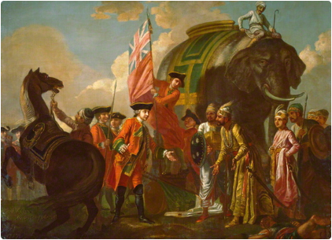
In the short term, the Battle of Plassey benefitted the Company and its officers in Bengal at the expense of the Indians. Clive immediately plundered the Siraj’s treasury, leaving the new nawab, Mir Jafar, Clive’s ally, with nothing. Clive took a jagir, an endowment of tax revenue for life (Keay 322), and, at the age of 33, became one of the richest men in England (Robins 73). The conquest profited the Company as well. The Mughal emperor, Shah Alam II, recognised British power by granting the East India Company a diwani. This office gave the Company official authority to collect taxes on 10 million Bengalis, making the Company the virtual rulers of Bengal (Robins 3). Within a few years, Bengal would account for 50% of all Company trade (Keay 272). Clive wanted more.
It’s hard to overstate the importance of the long-term consequences of the conquest of Bengal. Most historians look at this aggressive acquisition of territory as the first step in the rise of the British Empire in India. For this is the moment when the English East India Company shifted decisively from a trading company to a landlord and an occupying force. From its power base in northeast India, the Company expanded its territory quickly by playing local Indian princes and nawabs off against each other. The Company replicated the model in Bengal elsewhere, creating compliant puppet rulers so that it could rule territory efficiently and inexpensively. Throughout India, the Company used the name and authority of the disintegrating Mughal Empire for political cover. The Company now replaced and emulated the Mughal revenue system by relying on local rulers to collect taxes. Importantly, this new source of wealth obviated past trade practices of sending valuable silver from England to India. Bengal was the imperial “golden goose” that conquerors dreamed of.

The shift in share of World GDP from 1600 to 1879 (in millions of 1990 dollars (Robins 7)
 | 1600 | % of Total | 1700 | % of Total | 1870 | % of Total
Great Britain | 6,007 | 1.80 | 10,709 | 2.88 | 100,179 | 9.10
Western Europe | 65,955 | 20.02 | 83,395 | 22.46 | 370,223 | 33.61
China | 96,000 | 29.14 | 82,000 | 22.30 | 189,740 | 17.23
India | 74,250 | 22.54 | 90,750 | 24.44 | 134,882 | 12.25
World | 329,417 |  | 371,369 |  | 1,101369
For Bengalis, however, the British conquest was a tragedy. The most productive region in India was quickly reduced to poverty. Famine spread throughout the province as the British increased tax collection, decreased wages, and failed to respond to droughts and floods. In 1769, 1 to 10 million Bengalis died of famine (estimates vary widely because no official count was ever taken) (Robins XV). In the lower parts of Bengal the famine resulted in a population loss of between 33 to 50 percent (Keay 383). Throughout the famine, the Company continued to collect taxes and actually increased the land tax (Robins 92). They offered no food relief for the starving and, shockingly, some Company officials made fortunes by hoarding and charging exorbitant prices for food. Calcutta Company officials reported that they had actually increased revenues during the famine (Robins 92). Taking responsibility for the welfare of the people of Bengal was clearly not part of the Company’s mission. Under the British, Bengal also lost its role as a manufacturer of high quality goods and instead became dependent on exporting low-value raw materials, such as raw cotton, opium, indigo, and tea (Peers 48). Taking advantage of its monopoly on trade, the Company forced weavers to accept extremely low wages and the industry declined. By the middle of the 19th century, the Company had effectively de-industrialised Bengal.
Back in England, some critics attacked the Company’s meteoric rise to success and called for reform. In 1772, Parliament investigated the Company for its finances and how it conquered and ruled Bengal. The focus turned quickly to how Clive acquired his fortune. He defended himself vigorously, saying, “I stand astonished by my own moderation” (Wikipedia). Despite winning a knighthood and a seat in the House of Lords, he felt embittered by the public recriminations. Suffering from gallstones and opium addiction, he committed suicide in 1774 (Wikipedia and Keay 393). In any case, Parliament regulated the Company in 1773 and again in 1813, taking possession of territory, rescinding its monopoly on Asian trade, and allowing missionary activity for the first time (Keay 393). In a further blow to the Bengali textile industry, the regulations also included a 78% tax on imported Indian cotton to protect the incipient British textile industry (Robins 147). Bengali textile exports slowed and opium soon became the main export (illegally traded to China). Even with the new regulations, the East India Company continued to expand in India.
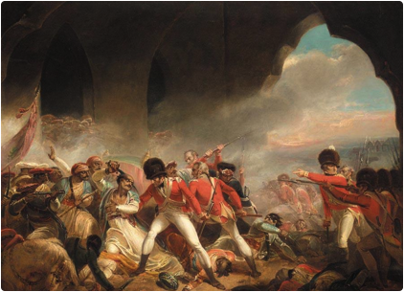
Despite an incomplete conquest, the Company ruled most of India by the early 1800s. They fought long and protracted wars against the Marathas and the Prince of Mysore, just as the Mughals had done. And the British failed to subdue the Sikhs in the Punjab, the last holdout, until 1848 (Peers 42-43). But, the East India Company vanquished the Mughal Empire in all but name. In 1803, in a telling reversal, the Mughal Emperor himself accepted the protection of the British Empire. The East India Company president in London was essentially the Emperor of India. The British Empire triumphed right along with the Company. With France’s defeat in the Napoleonic Wars in 1812, England rid itself of its last imperial competitor in Europe. The British Empire now ruled the seas as well as most of South Asia (Ferguson 56).
Academics and political leaders have for centuries reflected on the legacy of the English East India Company. Thomas Macauley, Victorian historian, poet, and former Indian administrator, deemed it “The Greatest Company in the World” (Robins 22). But, few took such a sanguine view. The champion of free market economics, Adam Smith, a contemporary of Clive, wrote of how the Company “oppresses and domineers” the Bengalis (4). Karl Marx, on the other side of the economic spectrum, disparaged how the East India Company had “conquered India to make money out of it” (38). And in the 20th century, the first Prime Minister of India, Jawaharlal Nehru, wrote of how the East India Company was full of “corruption, venality, nepotism, violence and greed of money” (13). Historian Nick Robins summarised the accomplishments of the Company this way in 2006: “The East India Company deserves to be looked at as it was—a profit making company that generated great wealth, but one the also contributed to great suffering” (16).

The Sepoy Uprising (1857-1858)
“In India one is always sitting on a volcano.”
—Lord Dalhousie, Governor-General of India, 1848 (Peers 66)
Historians still do not agree on the name: The Sepoy Rebellion, The Sepoy Mutiny, The Great Mutiny, The Indian Uprising, or The First War of Indian Independence. Historians do agree, however, that it came extremely close to suddenly and permanently ending British imperialism in India. It started when a small group of sepoys refused an order by their British officers. So it was definitely a mutiny. Some peasants and landlords also joined the uprising, so it was more wide spread than a mutiny. Yet, the majority of the Indian population did not join the uprising. More still, the majority of soldiers who put down the rebellion were Indians themselves. Historians do agree that the fighting was brutal. Both sides committed atrocities, often with thinly veiled racial and sectarian overtones. Of the 40,000 Europeans living in India, approximately one in seven perished. On the Indian side, at least 800,000 died in the uprising and the ensuing famine (Peers 64). The war also marked the end of the East India Company altogether. After the uprising, the British government ruled India directly and formally as a colony.
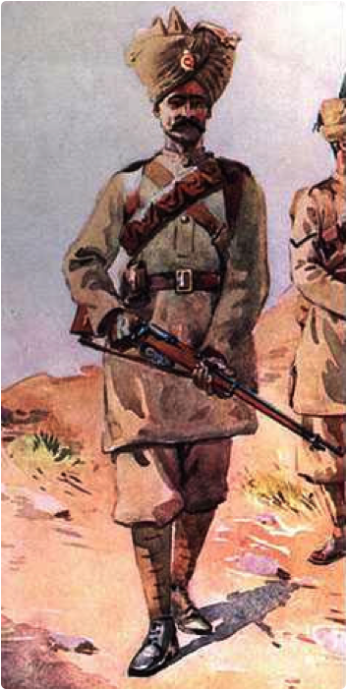
In the 19th century, the British increasingly unveiled ethnocentric attitudes and laws that belittled Indian culture. For example, one administrator famously unpacked his cultural arrogance declaring, “a single shelf of a good European library was worth the whole native literature of India and Arabia” (Dalrymple 69). Indians resented such disparaging attitudes. In 1837 the British made English the official language of the Indian government and offered it along with Christian Bible classes in colleges (Dalrymple 69). The 1813 Regulatory Act legalised Christian missionaries in India. Though the missions were largely unsuccessful in converting Indians, Muslims and Hindus felt threatened by this new religious challenge. Many people also resented laws that intervened in Indian culture, such as the Widow Remarriage Act of 1856 (Peers 67). Hindu women were traditionally expected to honour their families and show loyalty to their deceased husbands by refusing to remarry and choosing a life of poverty and self-denial. The new law allowed and encouraged Indian widows to remarry, a direct affront to Hindu traditions. Many Indians, including the sepoys, felt their culture was under siege.

Though they secured the British Empire against foreign and domestic threats, sepoys felt increasingly insecure in their homeland. British policies disrupted morale, attacked traditional customs, and threatened the livelihood of the Indian soldiers. Officers in the Indian Army were exclusively British. No matter how competent or experienced, sepoys faced a racial glass ceiling that prevented them from rising to higher positions in the army. Furthermore, the General Service Enlistment Act of 1856 required sepoys to serve outside of India whenever the Empire so demanded (Dalrymple 128, Fremont-Barnes 27, Peers 66). For the high caste Hindus who made up many of the sepoys, travelling across the ocean would deprive them of their caste. Also, the British governor-general in India implemented new ways to appropriate the property of Indian nobles. Any prince who died without a direct heir forfeited his land to the British (Fremont-Barnes 25). The province of Avadh in Bengal—home to a majority of the sepoys in the Indian Army—was annexed in 1856 on questionable grounds (Dalrymple 118, Peers 67, Fremont-Barnes 25). In retrospect, it seems unsurprising that this area of Bengal became the origin of the sepoy mutiny. In 1857, there were 311,000 sepoys, more than 7 times the number of European soldiers (Fremont-Barnes 20-21). One spark could ignite the growing frustrations into an uprising.
All these tensions exploded during a spontaneous sepoy mutiny that started with a rumour. Word spread that the bullet cartridges issued to soldiers for the new Enfield rifles would be greased in cow and pig fat. Soldiers would be instructed to bite off greased paper from a cartridge, resulting in Hindus and Muslims coming into direct contact with religious dietary taboos that would spiritually defile them (Dalrymple 125-126, Fremont-Barnes 28). Muslims do not eat pigs and for Hindus cows are sacred. To many Indians, this was yet another arrogant policy designed to degrade Indians and increase Christian converts. In fact, the new cartridges were never given to the troops and the army quickly ordered a change so that the bullets could be lubricated with spiritually clean mutton fat and wax (Fremont-Barnes 28). But the damaging rumour spread too fast and far to stop it.
The mutiny started on April 24, 1857 in the town of Meerut in Bengal, 40 miles from Delhi. Eighty-five sepoys—afraid to touch contaminated grease—refused an order to assemble for shooting practice. The army sentenced them to ten years in prison with hard labour. The extremely harsh penalty exacerbated the tension among the troops. The next day, sepoys, spurned by a local mob, shot a British colonel in the back as he tried to manage a crowd in the marketplace. The mutineers released the prisoners from jail, plundered British homes, and murdered British officers along with their families. (Fremont-Barnes 30-31). The mutineers and the civilian mob marched immediately to Delhi, where they declared a rebellion in the name of the Mughal Emperor, known as Zafar, who lived on a British pension and had no real political authority. The mutiny quickly spread east throughout Bengal.
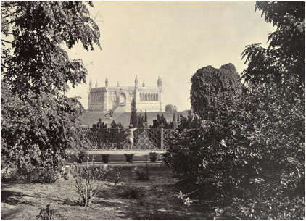
In June, in the town of Cawnpore, also in Bengal, rebels laid siege to a British army encampment. With no food, water, or ammunition left, the commanding officer surrendered to the sepoy rebels. Despite promising safe passage, the mutineers ambushed the unarmed British prisoners as they boarded a riverboat to leave. Then, the sepoys and the town mob massacred two hundred British women and children left back at the fort. Their bodies were thrown down a well (Peers 68). A British soldier who arrived soon after, described the remains of the Massacre at Cawnpore.
“I was never more horrified! The place was one of mass blood. I am not exaggerating when I tell you that the soles of my boots were more than covered with the blood of these poor wretched creatures. [I found] quantities of dresses, clogged thickly with blood, children’s frocks, frills, and ladies’ under clothing of all kinds, also boys’ trousers, leaves of Bibles . . . and hair, nearly a yard long; bonnets all bloody, and one or two shoes . . . All the way to the well was marked by a regular track along which the bodies had been dragged, and the thorny bushes had entangled in them scraps of clothing and long hairs. I have looked upon death in every form, but I could not look down that well again” (Fremont-Barnes 53).
The British soldiers and public responded to the Massacre at Cawnpore in much the same way they responded to the “Black Hole” of Calcutta during the conquest of Bengal a hundred years earlier. The British soldiers no longer fought to secure imperial rule but rather to avenge the brutal murder of women and children. A sergeant wrote, “The men are mad, and oh, how they go about swearing and vowing to avenge this atrocity. They are wrought up to the highest pitches of madness, and are burning to go at these murdering monsters” (Peers 69). A popular magazine in England captured the public mood: “Our house in India is on fire. We are not insured. To lose that house would be to lose power, prestige, and character—to descend in the rank of nations, and take a position more in accordance with our size on the map of Europe than with the greatness of our past glory and present ambition” (Peers 64).
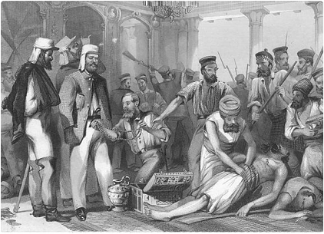
The rebel mob stormed into the old Mughal capital of Delhi, plundered the homes of wealthy citizens, massacred Christians, and co-opted the reluctant support of the eighty-two year-old Emperor. The slaughter of civilians took on a religious tone as the mob murdered European Christians but left European converts to Islam untouched. The Mughal Emperor, Zafar, tried and failed to convince the mutinous leaders to stop the execution of British prisoners, including diplomats and their families. A court reporter recorded the dramatic scene: “The king wept and besought the mutineers not to take the lives of helpless women and children, saying to them, ‘Take care—for if you commit such a deed the vengeance and angel of God will fall on us all. Why slay the innocent?’ But the Mutineers refused to listen” (Dalrymple 207).
The mood of many British settlers in India turned grim. The editor of the English language Delhi Gazette called for an avenging massacre in Delhi:
“The storm of revolutionary atrocity and fiendish crime have swept over the British occupants of Bengal, leaving behind it a wreck of horror and devastation, only equalled by the ingratitude and crime displayed by the Hell hounds who have originated and executed thus far their diabolical scheme of raising once again the standard of the lascivious Prophet, in opposition to the new dispensation offered to mankind, in the man Christ Jesus, the son of God”.
“Hindoo and Moslem have proclaimed their caste and their religion to the world in a mass of fiendish cruelty that stands as unparalleled in the world’s history. The punishment about to be inflicted will likewise be equivalent: Justice is Mercy—‘blood for blood’ will be the watchword throughout the storm pending over the doomed city; the British soldier must hurry: the Avenging Angel uses you in the massacre that awaits your advance on Delhi.” (Dalrymple 280).
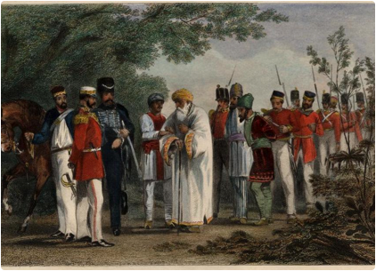
Using new technology of telegraphs to communicate and railroads to move troops, the British concentrated on the main rebel force in Delhi. Surrounded by seven miles of thick, high walls, the old Mughal capital seemed impenetrable (Fremont-Barnes 37). But conditions inside Delhi deteriorated over the course of a 3-month siege. The rebels suffered from a lack of water, military order, and a unified political vision. Enormous British artillery, brought by train, blew breaches into the old fort walls. Still, the British suffered heavy losses as they stormed the city. At one point the British general considered retreat. But, with the help of Sikh soldiers, the British just narrowly succeeded in recapturing the city after days of brutal street fighting (Dalrymple 342). The British exiled the Emperor to the colony of Burma. Almost all of his sons and successors were executed. He had spent his life preparing for a Mughal court from a bygone era—he spoke and wrote poetry in Urdu, Arabic, Persian, and Punjabi. He was the royal descendent of the great Genghis Kahn. Zafar (1775-1862), the last Mughal Emperor, soon died at the age of 87 and was buried in an unmarked grave in Burma.
The British army plundered Delhi for days and massacred many civilians just as the rebels had done. A 19 year old British soldier took part in the mayhem and described it:
“The orders were to shoot every soul. I think I must have seen about 30 or 40 defenceless people shot down before me. It was literally murder and I was perfectly horrified . . . and a few yards further on still some of our own drunken soldiers would reel past, exciting your pity not unmixed with disgust. Wherever you go, you see some unfortunate man or other being dragged out of his hiding place, and barbarously put to death” (Dalrymple 357).
The fear of spiritual debasement came full circle for the mutineers. The British deliberately defiled rebel sepoys that were caught. Some were blown from cannon. Some Hindus were smeared with cow fat before they were hanged. Some Muslim rebels were forced to chew pig fat (Peers 71).
There were many reasons why the spontaneous uprising failed. From the beginning, it lacked organisation and coordination to spread it further afield. Because the rebellion occurred mostly in the North, the small British army moved its troops from quieter parts of India and concentrated them on the rebel stronghold of Delhi. Though sepoy morale and motivation was usually high, the rebels lacked military leadership and discipline. Looting by rebel forces and a general lack of order scared off civilian support. As a result, few princes and local rulers backed the rebellion (Fremont-Barnes 86). Most importantly, the majority of troops in the imperial army were loyal Indians. Had they been less reliable, British rule would surely have come to an end. For example, Sikhs in the Punjab had only recently been conquered in 1848 but did not rebel. Instead, they became highly reliable imperial soldiers willing to volunteer to fight against the mostly Hindu Sepoy rebels (Peers 71).
The Sepoy Uprising left a lasting legacy. Neither side in the conflict conducted themselves honourably. The brutality of the war resulted in a climate of fear and distrust. The British no longer recruited sepoys from high caste Hindus in Bengal. Instead, the groups that proved their loyalty during the rebellion—such as the Sikhs from the Punjab—were given preferential access to the Indian Army. The British Empire would lean heavily on this Indian Army to keep the peace in India and abroad.

The British Raj Begins (1858)

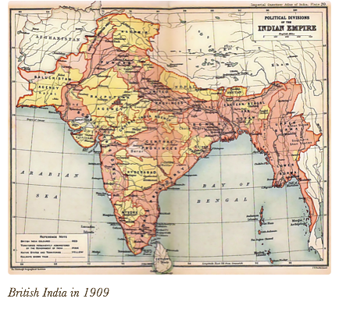
After 1858, Great Britain ruled India formally as a colony without the veil of the Company or the Mughal crown. Both the English East India Company and the Mughal Empire came officially to an end. The British Raj—Hindi for “rule” or “reign”—in India would last another 90 years (1848-1947). Queen Victoria became the Empress of India and in her Proclamation of 1858 she announced that all Indians would be treated equally under British law regardless of race or religion. Failure of the Raj to live up to her promises would later become fodder for Indian national movements (Peers 75-76). The stark contrast between British wealth and Indian poverty continued. In 1877, the year Queen Victoria lavishly celebrated her title as Empress of India, famine killed approximately 4 million Indians (75).
People, technology, and ideas now migrated and interacted more rapidly throughout British India. By the end of the 19th century, the Suez Canal and the prevalence of steam ships dropped travel time from Britain to India to just three weeks—as opposed to six months travel time 100 years earlier (Peers 11). Railroad building increased under the Raj both to encourage economic growth and to expand the benefit of moving troops efficiently across the country for security. Between 1860 and 1880, miles of railroad tracks increased from 836 miles to almost 10,000 (50). Industrial infrastructure could have negative consequences too. Railroads resulted in deforestation for railroad ties and fuel. During the era of peak railroad construction, builders chopped down 35,000 trees per year (14).
The British Raj relied on Indians to carry out the heavy lifting of imperial occupation and governance. As late as 1921, there were only 156,000 British citizens living in India, one for every 1,500 Indians (Copland 3). A cornerstone of the Raj, therefore, was a well-armed Indian army of over 200,000 who helped keep their fellow Indians in check if they threatened to revolt. In 1900, 30% of government spending went to paying for the Indian Army (32). The Raj also needed a large, cooperative, and efficient civil service of clerks and lawyers to govern India. To this end, the government invested in more secondary schools and a few colleges. In the twenty years between 1881 and 1901, annual high school graduates increased form 150,000 to 420,000 (31). The 30,000 college graduates in 1900, though a small fraction of the total population, would have the opportunity to enter professions such as medicine, education, journalism, and law (31). The Raj hoped that these native Indians would be willing to rule India for the British for years to come.
By 1900, the colony of India had become indispensible to the seemingly boundless imperial and industrial success of the British Empire. India had become the largest market in the world for British goods. By 1913, 60% of all Indian imports came from Britain (James 219). Despite the central position of India in the Empire, all was not well for the Queen’s subjects. Most continued to live in poverty and were vulnerable to diseases and natural disasters. For example, yet another famine in 1900 killed five million Indians and the Raj provided little relief (Copland 18). Even the small but rising Indian middle class resented various forms of institutional discrimination, such as the lower wages they received for equal work. Some looked for an outlet for their simmering frustrations.

The Rise of Indian Nationalism: The Indian National Congress and the Muslim League

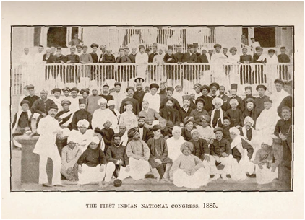
Despite Queen Victoria’s proclamation that all her subjects would be treated equally under British imperial law, discrimination led many educated Indians to seek redress. To that end, a small group of lawyers and merchants founded the Indian National Congress (INC) in 1885 in Bombay. The INC focused on pressuring the British to make constitutional reforms to ensure equal rights and increase Indian participation in the imperial government. At first the group met only once a year and had little influence. Over time, the Indian National Congress helped diverse ethnic, religious, and linguistic groups coalesce around the idea of resisting British rule. Could the diverse groups of people living in the South Asian subcontinent fuse together to form a single nation?

Before World War I, the Indian National Congress remained a small, upper class, urban movement that struggled to unify Indians. Communal splits—along religious lines—divided India politically. Though some Muslims did join, Hindus dominated the INC. In 1905, the British split the province of Bengal between Muslims and Hindus for local elections. Though short lived, the move worried Muslim leaders that, as a minority group, their rights and concerns would not be heard in democratic elections over the much larger Hindu majority. In 1906, wealthy leaders of the Muslim community founded the Muslim League at Dacca to protect the rights and privileges of the Muslim community in India. The British exploited this religious division in 1909 by introducing separate religious electorates in provincial elections (Fischer 115). From this moment on, under the British Raj, Hindus could only vote for Hindu candidates and Muslims could only vote for Muslim candidates. This solidified religious affiliation with political parties and decreased interreligious negotiation and discussion. Despite the communal divisions, these two organisations, sometimes working together and sometimes apart, would eventually lead India to Independence.

Ghandi

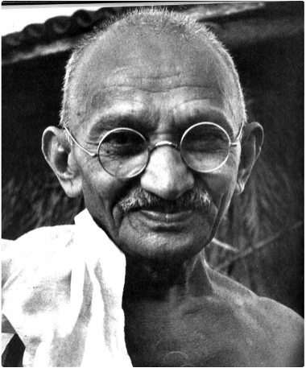
“Nothing but organised nonviolence can check the organised violence of the British government”
—Gandhi (Fischer 97).
Mohandas Karamchand Gandhi (1869-1948), the most eminent leader of the Indian Independence movement, and one of the most esteemed leaders of the modern world, embodied his parents’ beliefs and experiences. His illiterate Hindu mother modelled for him a life of unpretentious spiritual devotion. Just as Gandhi would do later in life, she fasted often, lived simply, helped those in need, and attended her local Hindu temple. Mirroring her humility, Gandhi would die with no formal title while the sum of all his earthly possessions would fit into a small backpack. Through her, Gandhi was also influenced by Jainism, which espouses non-violence and avoiding injury to all living beings. These ingrained beliefs would become the foundation of Gandhi’s civil disobedience campaigns. Though his mother was uneducated, his father was a government official who served as prime minister for a small princely state in Gujarat (Fischer 9). His father moved adeptly between the political worlds of the British imperial government and a weakened local Hindu prince. Gandhi would later show an aptitude for negotiating between British imperialists and the Indian nation. His father must have entertained some modern and Western aspirations for his son. He insisted that Gandhi study law at University College, London, in the capital of the British Empire. Both of his parents taught Gandhi his native Gujarati language. And they followed local tradition in arranging him to wed at the age of 13 (Fischer 10 and Wikipedia).
For twenty years, Gandhi practiced law in South Africa where his vision for civil disobedience gradually came into focus. He eschewed communalism and instead worked with Muslims, Hindus, and Christians to protect the civil rights of imperial subjects. He read Thoreau’s “Civil Disobedience” and Tolstoy’s “The Kingdom of God is Within You”—and corresponded with Tolstoy in a series of letters—to learn about western approaches to non-violence. He put civil disobedience to the test in South Africa when he successfully led non-violent protests against racist laws. He returned to India a hero in 1915. By 1920, Gandhi was the preeminent leader of the Indian National Congress.
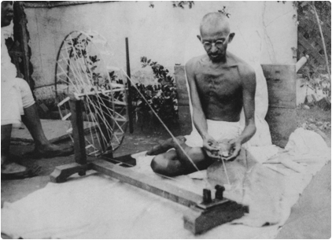
Gandhi’s vision for an independent India differed greatly from the West’s focus on industrialisation and imperialism. Gandhi did not completely reject Western technology, but he did not see evidence that it improved people morally and spiritually. “The spinning wheel is a machine; a little toothpick is a machine,” he said. “What I object to is the craze for machinery, not machinery as such. Today, machinery merely helps a few to ride on the backs of the millions. The machine should not tend to atrophy the limbs of man” (Fischer 86). In contrast, he believed people should live more simply, in small communities, and learn self-sufficiency by making their own clothes and food. Gandhi walked whenever possible, avoiding mechanised transportation, and scheduled time each day to spin his own cotton. He exchanged his Western suit and tie for an Indian dhoti (loin cloth), which identified him with the average peasant and their lifestyle. His decision to live in solidarity with the peasant way of life won over the vast majority of impoverished Indians to his side. This simple, spiritual national identity, Gandhi hoped, might unite Indians and lead them towards swaraj—self-rule or home rule.
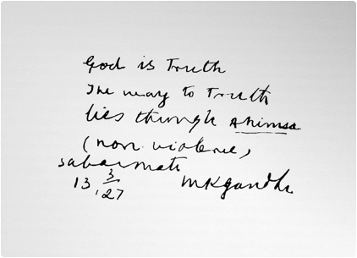
Gandhi wanted to use non-violent civil disobedience to achieve swaraj. Indians, he believed, must find a morally appropriate way to resist unjust laws. He called his strategy to overcome British imperial rule, Satyagraha or “truth-force.” Satyagraha is according to Gandhi, “the vindication of truth not by infliction of suffering on the opponent but on one’s self” (Fischer 35). The disciple of Satyagraha must resist unjust laws through his or her willingness to suffer consequences. Gandhi went to jail many times, spending a total of almost six years in prison (Fischer 148). Whether trying to reform Hindu beliefs in untouchability or British power in India, Gandhi sought to convert rather than humiliate or crush. As Gandhi charmed his nation, followers began calling him Mahatma, which means “great soul,” or Bapu, which means “father”.

Non-Violent Resistance: Amritsar and the Salt Protests
“There can be no question as to the permanency of British rule in India”
—Viceroy Lord Harding, 1912. (Copland 19).
Soon after Gandhi returned to India from South Africa, he led the Indian National Congress in calling for civil disobedience against the British Raj. Gandhi looked for a way to seize the moral advantage. He found it in the “anti-terrorism” Rowlatt Act, which allowed the British to arrest and detain any Indian without trial (Fischer 42). Gandhi and Congress called for a protest of the legislation that curbed basic civil liberties. Protesters disconnected telegraphs and railway lines and boycotted British goods. With the Sepoy Rebellion still in mind, the British government in India worried about the almost 1.5 million sepoys returning home from Word War I (Copland 21). How would they react to economic destitution and second-class citizenship they would find in India? Would masses of disgruntled Indian sepoys revolt as they did in 1857?
In the spring of 1919, tensions escalated into a massacre in the town of Amritsar, the Sikh capital in the Punjab. The local deputy commissioner arrested the Satyagraha leaders. When protesters went to the British commissioner’s house, guards fired on the crowd and killed several. Riots ensued in which several British and Indian civilians were killed. The local government declared martial law, which outlawed the right for groups to assemble in public. Either unaware of or undaunted by the declaration of martial law, thousands of locals gathered to attend an annual festival on April 13, 1919. General Dyer directed his company of fifty sepoys (ethnic Ghurkhas, Pathans, and Balucs) to fire without warning on over 10,000 unarmed Sikhs, Muslims, and Hindus (Fischer 67). The sepoys killed 379 and wounded over 1,137 in 10 minutes (Fischer 66). The wounded were left unattended. After the Amritsar Massacre, General Dyer was questioned about why he did not warn the crowd, stop firing, or attempt in any way to disperse the crowd: “It was no longer a question of merely dispersing the crowd, but one of producing a sufficient moral effect not only on those who were present, but more especially throughout the Punjab. There could be no question of undue severity…. I thought I would be doing a jolly lot of good” (Fischer 66-67). After a British investigation into the Amritsar Massacre, Dyer was forced to resign his post and retire. But, the local governor of the Punjab congratulated him on his “correct” action (Wikipedia). Back in Great Britain, conservative newspapers collected a retirement fund for him of 26,000 silver pounds, a fortune at the time (Wikipedia).
The Amritsar Massacre changed Gandhi’s focus from asking for equal rights to demanding Indian independence. In the eyes of the international community and Indian leaders, Britain had no moral right to rule 300 million Indians.
The INC announced a “non-cooperation” movement but then suspended it after it turned violent and twenty-two policemen were killed (Copland 49). Gandhi was arrested and spent four years in jail.

The Salt Protests
The most influential Satyagraha started with a pinch of salt. The Imperial government in India collected revenue by taxing salt. This policy touched all Indians, rich and poor, because it was a part of the daily diet. To break the British monopoly on salt, Gandhi led one of his most famous campaigns, a 241-mile walk to the sea to make salt. Before the march, Gandhi informed the viceroy of his plans and why he decided to do it. “Whilst, therefore, I hold the British rule to be a curse, I do not intend harm to a single Englishman or to a legitimate interest he may have in India . . . And why do I regard the British rule as a curse? It has impoverished the dumb millions by a system of progressive exploitation and by a ruinous expensive military and civil administration which the country can never afford” (Fischer 96). Gandhi’s March to the Sea in1930 attracted world attention. The march lasted almost two months and gained marchers as it passed through each village. At the time, Gandhi was sixty-one years old and averaged 12 miles a day. People were amazed at his vigour, and when journalists asked about his ambitious timetable, he responded, “The modern generation is delicate, weak, and much pampered” (Fischer 98). He arrived at the sea with thousands of marchers and illegally grabbed salt from the seashore. Peasants and Congress leaders followed suit. The imperial government responded with a strategy to fill the jails and imprisoned over 60,000 (Fischer 100). Still, the non-violent marches and protests continued.
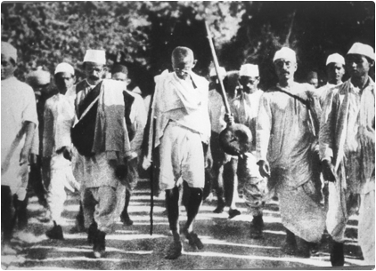

Gandhi’s most dramatic and influential civil disobedience protest was the Dharsana Satyagraha, which was also part of the salt protest. Ironically, he was unable to attend. Gandhi intended to march on the Dharsana salt factory. “Nothing but organised nonviolence can check the organised violence of the British government” (Fischer 97). As was his want, Gandhi informed the viceroy of his plans. He was promptly arrested just before the march. Though most Congress leaders were in jail, 2,500 volunteers participated. A famous poet, Sarojini Naidu, took over the leadership of the protest. She warned the marchers that they would be hit and made to suffer. But they must swear to take the blows without resisting or fighting back. The non-violent protesters stayed true to their vow. Two were killed and hundreds injured on the first day of the protest (Brendon 387). The Dharsana Satyagraha became a model for civil disobedience for the Civil Rights protests in the United States led by Martin Luther King Jr.
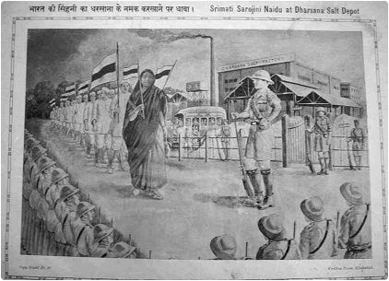
The Salt protests were the beginning of the end for the British Empire in India. The strategy of filling the jails failed and made the British aware that they would have to use force to get Indians to comply with the Raj. It also gave Indians a sense of their moral strength and identity. The Bengali artist, Rabindranath Tagore, the first non-European winner of the Nobel Prize in literature, described how the British Raj lost its moral legitimacy by reacting so violently to non-violent protests: “Europe has completely lost her former moral prestige in Asia. She is no longer regarded as the champion throughout the world fair dealing and the exponent of high principle, but as the upholder of Western race supremacy and exploiter of those outside her own borders. For Europe this is, in actual fact, a great moral defeat that has happened. Even though Asia is physically weak and unable to protect herself from aggression where her vital interests are menaced, nevertheless she can now afford to look down on Europe where before she looked up” (Fischer 102).
In response to the large-scale civil disobedience in India and international pressure abroad, the British agreed to hold roundtable discussions with Congress about the future of India. The British released the Satyagraha prisoners and Congress stopped the civil disobedience campaign. Prime Minister Winston Churchill could not contain his frustration and humiliation of having to negotiate with Gandhi. He was disgusted by the “nauseating and humiliating spectacle of this one time Inner Temple lawyer, now seditious fakir, striding half-naked up the Viceroy’s palace, there to negotiate and parley on equal terms with the representative of the King-Emperor” (Fischer 103). The viceroy that Churchill referred to staffed his opulent palace in Delhi with 6,000 servants and 400 gardeners (Ferguson 215). The disparities between the British rulers and the average Indian seemed wider than ever. The discussions were simply a short-term British strategy to enervate (drain of energy) the swaraj movement. It was a show for the media. The British invited Gandhi to London to negotiate. He wore his usual homespun peasant loincloth when he met the King and Queen. When someone asked if perhaps he was wearing too little clothes for such a formal meeting, Gandhi replied, “The King had enough on for both of us” (Fischer 105). In the end, Gandhi returned to India empty handed. Indian leaders who thought Independence would come quickly and smoothly were disappointed.

Independence: The Partition of South Asia
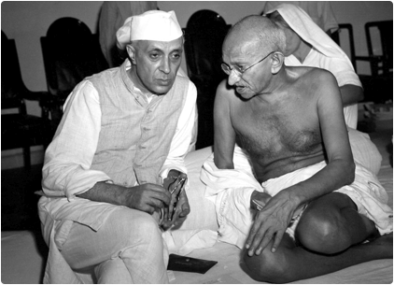
The final act of the Indian independence movement cast the Muslim League and the India National Congress into the spotlight, along with their two main leaders. With Gandhi’s blessing, the Indian National Congress voted Jawaharlal Nehru (1889-1964) as their leader and, eventually, the first Prime Minister of Independent India. Like Gandhi, Nehru attended secondary school in England: ironically, he studied at the elite Harrow School at the same time as the future Prime Minister of England, Winston Churchill (Brendon 380). Nehru studied law at the prestigious University of Cambridge and returned to India to take part in the swaraj movement. Gandhi helped Nehru become President of Congress in 1929: “He is pure as crystal,” Gandhi said. “ He is truthful beyond suspicion. The nation is safe in his hands” (Brendon 384).
Nehru, like Gandhi, worried that the British would bend to pressure from the Muslim League to divide India into separate countries according to religious boundaries. The leader of the Muslim League was Muhammad Ali Jinnah (1876-1948), another English educated lawyer. Like Nehru, he came from a wealthy family. For many years, Jinnah worked closely with the Indian National Congress and the Muslim League to resist British rule, but he became increasingly worried that Muslims would have little influence in a Hindu majority government. After 1940, he advocated for a separate country for Muslims. Jinnah and his counterpart Nehru in the Indian National Congress would largely determine the fate of a decolonised South Asia.
The civil disobedience campaigns of the Indian National Congress galvanised Indians to resist British rule, but forming a unified national identity would prove more challenging. When World War II started, the Indian National Congress refused to support British war aims, so the British government imprisoned leaders such as Gandhi and Nehru. The Muslim League, however, cooperated and won influence with the Raj. Jinnah called publicly for a separate Muslim state in South Asia to be called “Pakistan”—which means “land of the pure” in Urdu (Copland 61). The British took advantage of the division between Hindus and Muslims. Winston Churchill later confessed that British leaders at this time “regarded the Hindu-Moslem feud as a bulwark of British rule in India” (Brendon 388).
In the arena of international public opinion, the British Empire seemed on the wrong side of history. During World War II, U.S. President Roosevelt sympathised with jailed Congress leaders such as Gandhi and Nehru. He said, “I can’t believe that we can fight a war against fascist slavery, and at the same time not work to free people all over the world from a backward colonial policy” (Brendon 398). Prime Minister Winston Churchill was defiant: “I did not become the King’s First Minister in order to preside at the liquidation of the British Empire” (Fischer 135). Still, Roosevelt insisted that the U.S. would fight World War II to defeat the Nazis rather than defend the British Raj. Even in England, 77% of British citizens favoured Indian Independence in 1939 (Brendon 402). But Churchill disagreed with his own public. “Our continued existence as a great power is at stake”, Churchill thundered. “The loss of India would mark and consummate the downfall of the British Empire. That great organism would pass at a stroke out of life into history. From such a catastrophe there could be no recovery” (Brendon 390). But 2.5 million Indian soldiers also helped Britain win World War II and some 50,000 gave their lives (Khan 17). The sepoys, and most Indians, expected something in return for their loyalty.
After World War II ended, the British voted Churchill out of office, and the new British government, responsible for an economy devastated by six years of war, looked for ways to quickly step away from costly imperial possessions. The question now was when and how imperial India would become independent. The British viceroy released Indian political prisoners and asked Nehru to begin setting up an interim government. As discussions progressed about a new independent India, Jinnah and the Muslim League again took the initiative. On August 15, 1946, Jinnah called for a “Direct Action Day” for Muslims, which resulted in widespread communal rioting and the murder of Hindus and Muslims alike. Muslim leaders such as Jinnah never clearly explained what “Direct Action Day” meant. An advertisement for the protest that appeared in a Muslim League newspaper revealed a vague message:
“Today is Direct Action Day.
Today Muslims of India dedicate their lives and all they possess to the cause of freedom.
Today let every Muslim swear to Allah to resist aggression.
Direct action is now their only course.
Because they offered peace but peace was spurned.
They honoured their word but they were betrayed.
They claimed liberty but they were offered Thraldom.
Now might alone can secure their right” (Khan 64).
Local politicians were left to interpret for themselves what they should do, and the results were disastrous. For example, the mayor of Calcutta chose to incite violence and lend legitimacy to the communal pogroms: “We Muslims have had the crown and have ruled. Do not lose heart. Be ready and take swords. Oh kafir! Your doom is not far and the greater massacre will come” (Khan 64). Five thousand were killed and fifteen thousand wounded in just the first four days of rioting in Calcutta alone (Fischer 160). The violence spread to other communities throughout India where Hindus and Muslims lived in mixed communities. This was the start of widespread communal violence that, in the end, killed hundreds of thousands and teetered towards civil war.
In March 1947, the British government sent a new and final viceroy, Lord Mountbatten, to negotiate a comprehensive settlement for independence. As rioting spiralled more and more out of control, the viceroy became convinced that British rule had to end as soon as possible. In June 1947, Mountbatten suddenly moved up the date of Independence ten months to August 15, 1947, leaving just two months to finish all details of the complex negotiations. Gandhi adamantly opposed the division of India. “In the India that is shaping today there is no room for me” (Fischer 174). Because of the widespread communal violence, however, Congress saw no choice but to abandon Gandhi and support partition. Regions with a Muslim majority became Pakistan, while regions with a Hindu majority became India. The National Independence Days for Pakistan (August 14, 1947) and India (August 15, 1947) should have been a cause for optimism and celebration. Gandhi did not participate in the festivities. Instead, he fasted and prayed.
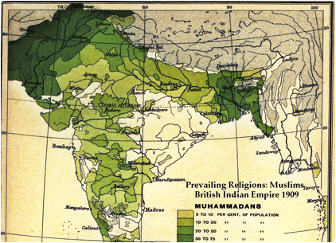
Nobody was happy with the new 3800-mile boundary drawn up between the two countries. The simple religious criteria for division proved messy and chaotic in practice. The unenviable task had been left to a British judge and Imperial mapmaker named Radcliffe, who had never been to India, stayed in India only six weeks to research and complete the maps, refused to visit any sites in India, and based his decisions on census data that was at least six years old. The results of Radcliffe’s Boundary Commission were not released until August 17 so as not to spoil the independence celebrations. Confusion and vicious communal violence ensued. Radcliffe’s zigzagging lines in the Punjab paid no attention to property ownership, traditional pilgrimage routes, language boundaries, or railways. Sikhs abandoned land in Pakistan en masse and marched to the eastern Punjab in India to take land from Muslims (Sarila 285). Sikh, Hindu, and Muslim soldiers disbanded to join religious militias that helped mobs carry out ethnic cleansing. Radcliffe’s commission also divided up the province of Bengal along religious lines, ignoring common culture and the Bengali language.
The independence celebrations of India and Pakistan quickly turned into national tragedies. Thirteen million Hindus, Sikhs, and Muslims migrated in just a few months, mostly to and from the divided areas of the Punjab and Bengal, to join areas where their religion was a majority. It was the largest migration in recorded history at the time (Copland xviii). Most families were forced to flee their homes with little or no preparation, leaving their property and possessions behind. Most tragically, almost one million died in the bloody and tragic civil war (Brendon 418). As Indian historian Yasmin Khan concluded, “Partition is a lasting lesson of both the dangers of imperial hubris and reactions of extreme nationalism” (Khan 210).
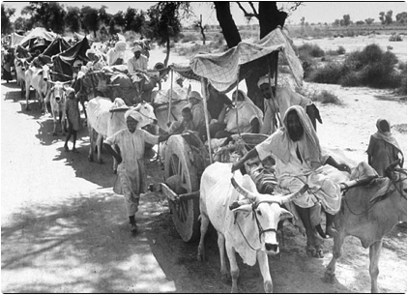
The tragedy continued when the non-violent leader of Indian independence, who had worked so hard for unity and peace, was murdered just as India descended into civil war. Gandhi had failed to prevent the partition of India and the communal violence between Hindus and Muslims. He fasted successfully to stop violence in Calcutta. But, on January 30, 1948, a Hindu nationalist, 35-year-old Nathuram Godse, shot and killed Gandhi as he headed towards his daily prayers (Copland 77 and Copley 98). Godse, and Hindu nationalists like him, were upset that Gandhi had not defended Hinduism strongly enough. Despite his death, Gandhi’s legacy continued to inspire the Indian national identity and non-violent civil rights movements in South Africa and the United States.
The Legacy of the British Raj
What is the legacy of the Raj? On the one hand, the British improved agricultural productivity by helping to irrigate 25% of arable land—a fourfold increase from 1858 to 1947 (Ferguson 216). They also established a coal industry, where none had existed, that produced 15 million tons of coal per year by 1914 (216). Life expectancy increased gradually from 21 to 32 years of age between 1820 and 1947 (216). Independent India also inherited British parliamentary democracy and became the largest democracy in the history of the world. On the other hand, the Raj left India underdeveloped, deindustrialised, and stuck in a cycle of low wages and low investment in education. At the end of British rule, about fifty percent of Indians lived in poverty and 88 percent could not read or write (Marshall 362). While average life expectancy increased, it still remained very low at 32 years of age in 1947. Indian economic growth disappointed throughout British rule. Between 1757 and 1947, British GDP increased 347% while Indian GDP only increased 14% (Ferguson 216). Successor states of the Raj—India, Pakistan, Bangladesh, and Sri Lanka—suffered through civil wars and became among the poorest countries in the world. So, did British imperialism improve India? It’s debatable. Although historians resist positing counterfactual questions, it is perhaps helpful to at least consider whether life would have been worse under the Mughals.

